Table of Contents

Precautions……………………………………………………...…2
Concept for Variable Frequency Power Supply System…………..3
Block Diagram for Operation of HY Series of Variable Frequency Power Supply………………………………………………………4
Method for Selecting Power Capacity……………………………..5
Instruction for Control Panel of Variable Frequency Power Supply
………………………………………………………….……….…6
Installation Instruction…………………………………..…………8
Operating Instruction……………………………………….……..10
Specifications for Electrical Equipment……………………..……12
Exception Handling………………………………………….……13

Precaution

- Thanks for purchasing the product from our company. Always read this manual carefully before using the product and keep it securely.
- Please carefully move and set the machine to avoid impact.
- Please construct according to the Installation Instruction.
- Please operate in order according to the steps indicated in the Operation Instruction.
- Never open the cover to avoid electric shock and damage to the machine.
- Please keep the machine clean.
- Never place the machine in humidity, swelter and direct sunlight.
- In case of exceptions, please refer to the procedure “Exception Handling”.

Concept for Variable Frequency Power Supply System

Variable frequency power source outputs the alternating current of utility power as the pure sine wave by means of AC→DC→AC conversion. The output frequency and voltage are adjustable within a certain range. AC power source is different from AC speed regulating controller used for motor speed regulation and common AC voltage stabilized power source.
The ideal AC power source features stabilized frequency, stabilized voltage, zero internal resistance and pure sine wave voltage waveform (no distortion). Variable frequency power source is very close to ideal AC power source. Therefore, the developed countries tend to use the variable frequency power source as the standard power source, so as to provide the electric devices the most excellent power-supplying environment, which is convenient to objectively test technical performance of the electric devices. The variable frequency power source mainly consists of two types: Linear Amplifying and SPWM Switching.
HY series programmable power source takes microprocessor as its kernel, is made with SPWM techniques, designed with active component IGBT module, uses such techniques as digital frequency division, D/A conversion, instantaneous feedback and sinusoidal pulse width modulation, has a single machine capacity of up to 150KVA to isolate the transformer output to enhance the complete machine’s stability, characterizes strong load adaptability, high quality output waveform, easy operation, small size and light weight, features short circuit, over current, over load and over heat protection functions to ensure reliable operation of power source.

Block Diagram for Operation of HY Series of Variable Frequency Power Supply
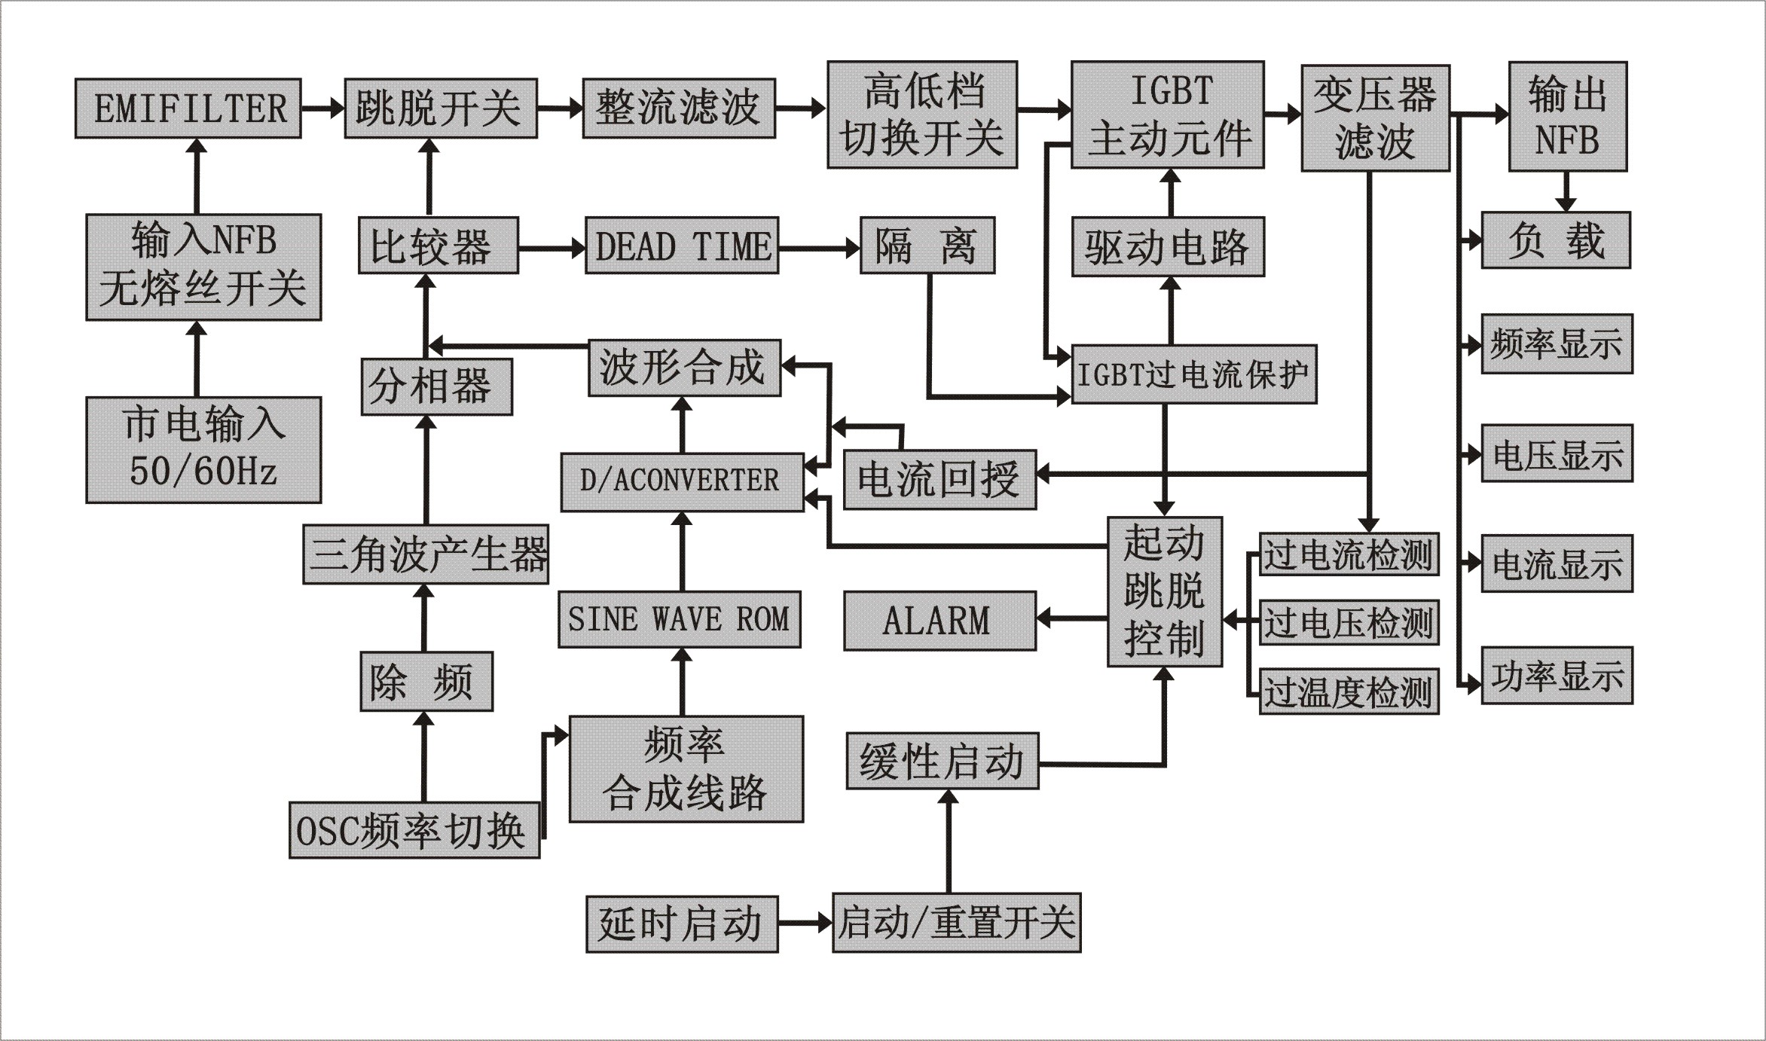
EMIFILTER | EMIFILTER
跳脱开关 | Tripping Switch
整流滤波 | Rectifier Filter
高低档切换开关 | Switch between High and Low Voltage
IGBT主动元件 | IGBT Active Component
变压器滤波 | Transformer Filter
输出NFB | Output NFB
输入NFB无熔丝开关 | Input NFB without fuse switch
比较器 | Comparator
DEAD TIME | DEAD TIME
隔离 | Isolation
驱动电路 | Drive Circuit
负载 | Load
市电输入 | Mains Input
分相器 | Phase Separator
波形合成 | Wave Synthesis
IGBT过电流保护 | IGBT Over Current Protection
频率显示 | Frequency Display
电压显示 | Voltage Display
电流显示 | Current Display
功率显示 | Power Display
D/ACONVERTER | D/ACONVERTER
电流回授 | Current Feedback
三角波产生器 | Triangle Wave Generator
SINE WAVE ROM | SINE WAVE ROM
ALARM | ALARM
起动跳脱控制 | Start Tripping Control
过电流检测 | Over Current Test
过电压检测 | Over Voltage Test
过温度检测 | Over Temperature Test
除频 | Frequency Divider
OSC频率切换 | OSC Frequency Switch
频率合成线路 | Frequency Synthesis Circuit
缓性启动 | Slow Start
延时启动 | Delay Start
启动/重置开关 | Start/Reset Switch

Method for Selecting Power Capacity

1. Resistance: Power Source Capacity = 1.1×Load Power
Load Starting Current
2. Inductive: Power Source Capacity = ─────── ×Load Power
Load Rated Current

Wave Crest Coefficient for Load Current
3. Rectification: Power Source Capacity = ───── ×Load Power
1.5
4. Mixed: Please select an appropriate power source capacity according to the percentage of different loads.
Note: For the inductive loads like refrigerator and air conditioning, the power source capacity should be selected based on the start power.

Instruction for Control Panel of Variable
Frequency Power Supply

All items on the panel are described orderly from left to right, from top to bottom.
- Frequency Display Window: 3-digit LED display; display the preset output voltage frequency at presetting; display the actual output voltage frequency at operating. Unit: Hz
- Voltage Display Window: 4-digit LED display; display the preset output voltage at presetting; display the actual output voltage at operating. Unit: V
- Current Display Window: 4-digit LED display; display “0” at presetting; display the actual output current at operating. Unit: A
- Power Display Window: 4-digit LED display; display “0” at presetting; display the actual output power at operating. Unit: KVA
- “Shortcut” Key: quickly select 50Hz/220V, 60Hz/110V and 60Hz/120V.
- 50Hz/220V Indicator: The solid indicator during operating shows the output voltage is 220V and frequency 50Hz.
- 60Hz/110V Indicator: The solid indicator during operating shows the output voltage is 110V and frequency 60Hz.
- 60Hz/120V Indicator: The solid indicator during operating shows the output voltage is 120V and frequency 60Hz.
- “Preset” Key: In the standby mode, press the key to enter the preset status. At this point, you can press the “ Plus ” and “ Minus ” keys to preset the output voltage frequency and output voltage in order. During operating, you can press this key to adjust the output voltage frequency and output voltage.
- “Plus ” Key: Press this key to increase the preset value in the preset status.
- “Minus ” Key: Press this key to reduce the preset value in the preset status.
- “Start” Key: Press this key to enter the operating status. The output indicator will light.
- “Stop” Key: After this key pressed, the power source will stop outputting and return to the standby status.
- Output Indicator: The power source has voltage output when the indicator lights.

Installation Instruction

1. Please refer to the following specifications before installation.
Input: 220V Single Phase Power Source
Model | Input |  |  | Output
HY | Max. Current | Protection Switch | Wire Diameter | Max. Current | Wire Diameter
500VA | 2.5A | 3.5A | 0.5mm^2 | 110V：4.2A  220V：2.1A | 1.00mm^2  0.50mm^2
1KVA | 5A | 6.5A | 1.0mm^2 | 110V：8.4A  220V：4.2A | 2.00mm^2  1.00mm^2
2KVA | 10A | 13A | 2.0mm^2 | 110V：16.8A  220V：8.4A | 3.50mm^2  2.00mm^2
3KVA | 15A | 20A | 3.0mm^2 | 110V：25.0A  220V：12.5A | 5.00mm^2  2.50mm^2
5KVA | 25A | 33A | 5.0mm^2 | 110V：42.0A  220V：21.0A | 8.00mm^2  4.00mm^2
10KVA | 50A | 65A | 10.0mm^2 | 110V：84.0A  220V：42.0A | 16.00mm^2  8.00mm^2

Input: 380V Single Phase Power Source
Model | Input |  |  | Output
HY | Max. Current | Protection Switch | HY | Max. Current | Protection Switch
15KVA | 25A | 33A | 5.0mm^2 | 110V：126.0A  220V：63.0A | 25.00mm^2  13.00mm^2
20KVA | 34A | 44A | 7.0mm^2 | 110V：168.0A  220V：84.0A | 35.00mm^2  17.00mm^2
30KVA | 50A | 65A | 10.0mm^2 | 110V：250.0A  220V：125.0A | 50.00mm^2  25.00mm^2
45KVA | 76A | 100A | 16.0mm^2 | 110V：378.0A  220V：189.0A | 76.00mm^2  38.00mm^2
60KVA | 100A | 130A | 30.0mm^2 | 110V：500.0A  220V：250.0A | 100.00mm^2  50.00mm^2
100KVA | 170A | 220A | 50.0mm^2 | 110V：750.0A  220V：375.0A | 150.00mm^2  75.00mm^2
- Determine the input voltage before using the power source.
- Before connection to the power source, please make sure the G-N-L (single phase) specification is correct and the phase sequence for N-A-B-C (three phase) is configured correctly.
- Before connection to the power source, turn all switches to OFF to make sure the device has no possible damage.
- The power source can only be connected when the device specification exactly match that of the power source system.

Operation Instruction

- When the variable frequency power source is connected to the power source, please turn on the device. Then it begins to count down, and any key can’t be used at this point, and then it enters the standby status and all display windows will display as follows:
Frequency Display Window: Original Preset Value
Voltage Display Window: 0.000V
Current Display Window: 0.000A
Power Display Window: 0.000kVA
- Press the “Shortcut” key to select 50Hz/220V, 60Hz/110V or 60Hz/120V.
- Press and hold the “Shortcut” key until the indicators 6, 7 and 8 indicated on the panel diagram are all extinguished, and then press the “Preset” key. The device will enter the frequency and voltage preset status. Press once the “Preset” key, and the value on the frequency display window will flash. At this point, you can press the “Plus ” and “Minus ” keys to preset the output voltage frequency. (Note: if the power source you select has a frequency value of 400Hz, you can preset the output voltage frequency up to 400 Hz from 70.0Hz by pressing the “Plus ” key.) Press the “Preset” key again, and the value on the voltage display window will flash. At this point, you can press the “Plus ” and “ Minus ” keys to preset the output voltage.
- After the presetting is complete, press the “Preset” key to return to the standby status. The device will automatically memorize the preset parameters. At powering on next time, the device still keeps the preset parameters.
- Press the “Start” key and the device will run. At this point, the voltage display window displays the actual output voltage; the frequency display window displays the actual output voltage frequency; the current display window displays the actual load current; the power display window displays the actual power. Meanwhile, all corresponding indicators will light.
- If you want to change the output voltage and frequency of the power source during operating, you can press once the “Preset” key. The value on the frequency display window will flash. Then press the “Plus ” and “ Minus ” keys to adjust the output voltage frequency; press the “Preset” key again, and the value on the voltage display window will flash. At this point, you can press the “Plus ” and “ Minus ” keys to adjust the actual output voltage. After the adjustment is complete, please press the “Preset” key again to return to the normal status.
Note: 1) In the operating status, the frequency and voltage values adjusted will not memorized;
2) Level change must be performed in the standby status by the “Preset” key (low level 0V~150V; high level 151V~300V).
- When the “Stop” key is pressed, the device will stop outputting and return to the standby status.
- The device will stop running at powering off in the standby status.

Specifications for Electrical Equipment

Model ※ HY8002
Output Capacity ※ 2 KVA
Circuit Type ※ （IGBT）MPWM (Pulse Width Modulation)
Input Voltage ※ 220V±10%
Input Frequency ※ 50Hz/60Hz±5%
Output Voltage ※ (LOW)0～150V,（HIGH）151V～300V。
Output Frequency ※ 45.0—70.0 Hz Adjustable, 400Hz (Optional)
Load Regulation ※ ≦0.5%
Frequency Stability ※ 0.1%
Waveform Distortion Rate ※ ≦2%
Efficiency ※ ≧85%
Output Meter ※ Frequency Meter, 3-digit RMS Digital Frequency Meter
Voltage Meter, 4-digit RMS Digital Voltage Meter
Current Meter, 4-digit RMS Digital Current Meter
Power Meter, 4-digit RMS Digital Active Power Meter
Protection Device ※ Overload, short circuit, over-voltage, over-current, over-heat protection and alarm devices.
Dimension (W x H x D) ※ W x H x D (mm)
Operating Environment ※ Temperature 0~40℃ Relative Humidity 0~90%

Exception Handling and Maintenance

If the device has a failure during running, the internal protection circuit of it will automatically turn the power inverter off and stop outputting, and meanwhile the power display window will show the failure code and the buzzer will give off an alarm. At this point, please press the “Stop” key to eliminate the alarm, power the device off, and then resolve related failures based on the failure codes or contact the technical service department of the company.
Failure Code | Cause | Troubleshooting
—01— | Power Module Protection | Consecutively press the Stop key to return to the standby status, and then restart.
—02— | Over Load | Reduce the load or increase the power capacity.
—04— | Over Heat | May be caused by too high temperature of operating environment, heavy load or fan. Please handle based on specific conditions.

Operation Notes:
- The device shall be operated in the defined environment. The installation environment must be regarded to make best use of its function and prolong its service life:
- Avoid rain, humidity, high temperature, over heat or direct sunlight. The distance between the heat dissipation vent and its peripheral objects shall not be less than 40cm.
- Never operate in the place where there are caustic liquid or gas, and excessive dust, conductive fibers or metal particles.
- Never operate in the place of vibration or electromagnetic interference.
- Avoid of long-term upside-down storage and shipment, and prevent strong impact.
- Please note the following conditions when using the device:
- The input voltage shall not be too low or too high (198V~242V), otherwise the power module will not operate properly and the power display window will show “01” (power module protection) and give off an alarm.
- Never power the device off during operation.
- Changing the output voltage frequency can only performed in the preset status.
- Never touch the electrified positions of the device to avoid electric shock during operation.
- The disqualified personnel are not allowed to open the enclosure.
Maintenance
- We will guarantee to keep the product in repair for 12 months. During the period, the failure not caused by personal factors can be repaired free of charge.
- We will only charge for the maintenance cost beyond the warranty period of the product.

Dongguan Huayang Electronics Technology Co., Ltd.
Customer Service Tel: 86(769)-85471496
Fax: 86(769)-85359276

